PROCEEDING OF HIGHER EDUCATIONAL INSTITUTIONS
№ Х (ХХХ) TEXTILE INDUSTRY TECHNOLOGY 2022

УДК filled in by the authors
DOI filled in by the editors

TITLE IN RUSSIAN∗

TITE IN ENGLISH

AUTHOR FULL NAME 1, AUTHOR FULL NAME 2, AUTHOR FULL NAME 3

AUTHOR FULL NAMES IN ENGISH – no more than 5 coauthors

(¹ Places of Employment of Author 1 и 2,
Place of Employment of Author 3 and etc.)

(¹ Places of Employment of Author 1 и 2,
Place of Employment of Author 3 and etc. in English)
E-mail:

Abstract text (no more than 10 sentences with brief characteristic of research methods and working results).

Abstract text in English (no more than 10 sentences with brief characteristic of research methods and working results).

Keywords: word 1, colocation 2 and etc.

Keywords: word 1, colocation 2 and etc. in English
The text of the article with links to sources
Example:
Technologies for producing composites based on thermosetting resins of various viscosities and chemical activity are rapidly developing and improving. [1]. In a number of reviews, technologies for the production of products from composite materials based on a thermoplastic matrix [2], laser technologies [3], technologies for the additive production of composites are being actively introduced [4].
Subtitle 1
The text of the article with links to source.
Subtitle 2
The text of the article with links to sources, figures and tables
Example: The volume of the materials market, according to various estimates, ranged from 90.6 to 93.6 billion dollars in 2019 (Fig. 1 - an estimate of the global market for polymer composite materials) and approximately 12.0 million tons in physical terms.

Fig. 1 (no title, the drawing itself is given at the end of the article and in a separate file)

The practical possibility of introducing PCM into various sectors of the economy seems interesting. On Fig. 2 shows the structure and volume of consumption of PCM and products made from them by sectors of the economy in 2020 [2].

Fig. 2

We used the technical requirements for threads, from which we select threads of the highest linear density, the parameters of which are summarized in Table.1.

Table.1. (no title, the table itself is given at the end of the article and in a separate file)

Formulas (1-3) were used for calculation:

formulas (1), (2), (3)
(the formulas themselves are given at the end of the article and in a separate file)

Conclusions
Conclusion text.

R E F E R E N C E S

1. Donetskskiy K.I., Dushin M.I., Mishchun M.I., Sevastyanov D.V. Some features of the using of semi-pregs for vacuum molding of PCM (review) // Proceedings of VIAM. – 2017, №12 (60). С.81…93.
2. Wang Y., Zhou Y., Lin L., Corker J., Fan M. Overview of 3D additive manufacturing (AM) and corresponding AM Composites // Composites Part A. – 2020, 139. Р. 106…114.
3. Ershov S.V., Suvorov I.A., Kuznetsov V.B., Nikiforova E.N., Kalinin E.N. Synthesis of a 3d model of a woven reinforcing structure of a textile composite using the methodology of numerical object-oriented modeling // Izvestiya Vysshikh Uchebnykh Zavedenii, Seriya Teknologiya Tekstil’noi Promyshlennosti. - 2021, 1. P. 114 ... 119.

Recommended by the department (Name of the structural unit and university. Received (no date).

1. Figures:
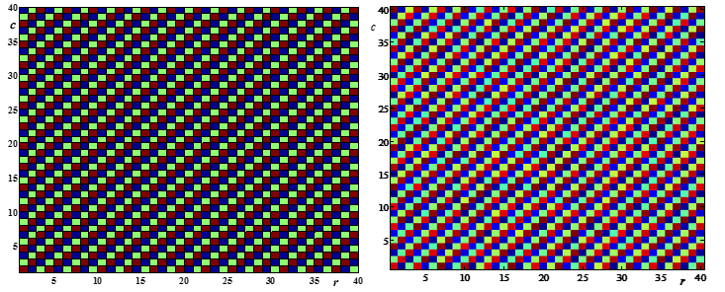

a) b)
Fig. 1

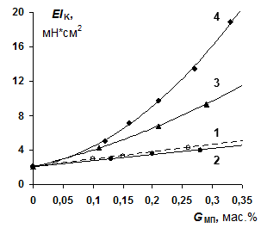
Fig. 2

2. Tables

Table 1
Параметр | Вид нити
 | Углеродная | «Урал» | Арамид | Полиамид
Объемная плотность, г/см³ | 1,80 | – | 1,45 | 1,15
Линейная плотность, текс | 1040 | 800 | 840 | 800
Диаметр нити, мм | 0,54 | – | – | –

3. Formulas:

$W_{z}=\frac{πr^{3}}{4}=\frac{πr_{max}^{3}}{4}{\left(1-\frac{x}{l}\right)}^{3};$ (1)

$r=r_{max}-\frac{r_{max}}{l}x=\frac{r_{max}}{l}\left(l-x\right)=r_{max}\left(1-\frac{x}{l}\right);$ (2)

∗ The work was carried out with financial support of grant (if available) (Name of the Fund, number and name of the project) – if the work was not funded, delete this link

